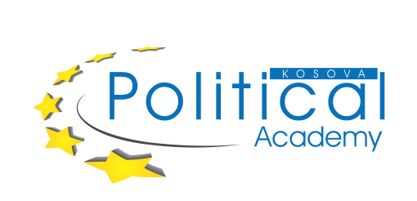
Call for Applications
for the
Political Academy of the Friedrich-Ebert-Stiftung 2021

The Political Academy of the Friedrich-Ebert-Stiftung combines political education and practical training in a variety of disciplines. Its purpose is to educate and train individuals with progressive ideas and a progressive vision based on values such as freedom, social justice and solidarity, equality and antidiscrimination.
The program which is designed to provide both theoretical knowledge and practical skills aims to enable active, bright and visionary young people to enhance their knowledge and acquire new skills to enable them to actively deal with social and political issues that are of concern to the entire society in Kosovo.
Therefore, the Friedrich-Ebert-Stiftung organizes an academy in the period from 11.09.2021 to 18.09.2021 (eight-day training seminar). Please be informed that in accordance with government restrictions due to the Sars CoV-2 pandemic, the dates for the academy are subject to change.

Terms and Conditions of participation
The call for applications is addressed to:
- Every citizen of Kosovo at the age 20-35, who is studying and/or is active in the public life in Kosovo (NGO sector, private sector etc.)
- Everyone who shares the values outlined above: freedom, social justice and solidarity, equality and antidiscrimination
- Everyone who is politically or socially engaged or intends to become active in social and political life in the future
- Everyone with a basic knowledge of social and political sciences
- Everyone with a good knowledge of English (in speaking and writing)

If these criteria apply to you, please submit your application
- CV with contact details (in English)
- Motivation letter (in English, max. 1 page, A4, Times New Roman 12, Paragraph 1.5)

Selection of candidates
Both female and male candidates as well as candidates of every ethnicity and every religion are encouraged to apply! The selection process consists of two phases. In the first phase, candidates will be pre-selected based on their personal achievements (including academic education, informal education, work experience, voluntary work and internships) mentioned in the CV and the essay.
Qualified candidates will be invited to an interview, taking place during the last two weeks of May. Interviews will be conducted in English. Upon regular and active participation, the participants will receive a certificate for the successful completion of the program.

Everybody interested in participating in the program of the Political Academy pays a participation fee of 50, - Euros once they have been accepted and have received the acceptance letter via e-mail.

Deadline for application
Applications must be submitted no later than 21.05.2021 (5:00 p.m.) by sending the required documents to jeta.loshaj@fes-kosovo.org

